
Community Service is one of the five Areas of Interaction and is integral to the IB experience. Sixth, seventh, and eighth graders will be expected to participate in at least 20 hours of community service by May 6, 2016. Community Service is defined as volunteer service that will benefit the community, usually through a non-profit organization, including schools. For service ideas, check http://www.serve.gov/ .
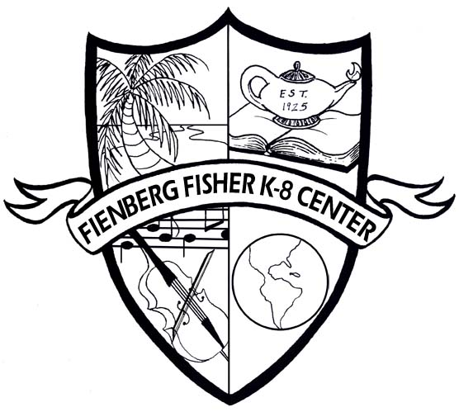
Fienberg Fisher K-8 Center
International Baccalaureate MYP
Community and Service Reflection Sheet

Students must use this form to log hours and to reflect on community service participation. It is the student’s responsibility to turn this form in to his/her teacher every quarter or as directed.

Student Name _______________________________ Grade ______ School Year ________

Community Service Log

Date | Place | Activity/Role | Hours | Supervisor Signature & Contact Info

Total Hours This Page ____________

Reflection

You have been helping your school or community in a special way. Use the questions below to reflect on your experience.

Describe what you did:
__________________________________________________________________________________________________________________________________________________________________________________________________________________________________________

What skills did you need to complete your service?
____________________________________________________________________________________________________________________________________________________________

Describe 2-3 ways this experience changed the way you see things:
_________________________________________________________________________________________________________________________________________________________________________________________________________________________________________

Describe the impact or positive effect of your service: ________________________________________________________________________________________________________________________________________________________________________________________________________________________________________________________________________________________________________________________

What did you learn from your community service project?
__________________________________________________________________________________________________________________________________________________________________________________________________________________________________________

